*The project synopsis may be of* ***2 – 3 pages*** *and shall be simple, straightforward depicting your project study and tools and techniques applied.*

|  |  |  |
| --- | --- | --- |
| **Group No.** | **Group Members (Regd. No.)** | **Project Title** |
|  | *Bali Babu Chauhan(1941012812)*  *Rajshri Gupta (1941012812)* | *Pico snake fun game.* |
|  |

1. **Introduction:** (*Details about the Topic, industry, products, need of study and some history about the same etc.)*

This is a fun snake game where the snake moves around and eats the food.

The size of snake and position of food changes as the game proceeds further.

Products used-

microcontroller (raspberry pi pico), push-buttons, oled display, jumper wires, resistors, buzzer, switch.

The controller for all the directions snake will move is made using four push-buttons and the movement of snake and the food is shown in the oled screen.

After the snake eats the food or the game over tune will coming from the buzzer.

1. **Problem identification and Problem Formulation: (***Core area of problems or other related problems and their brief solutions***)**

In the pico snake game snake moves around the oled screen and the movements are made so that the snake can eat the food. As the snake eats the food, the size of the snake increases and the position of the food is changed.

This goes on repeatedly until the snake collides with any end if the screen or the snake eats it’s own tail and when that happens “Game Over” is displayed on the screen and a sound comes from the buzzer.

1. **Objective of the Project: (***Objectives should be mentioned pointwise. Students can also divide the broader and narrow areas of the objectives. These objectives must be near to the situation of the problems***)**
   1. To implement the snake game using the microcontroller
   2. Pull up and pull down mechanism using pushbuttons and oled screen
2. **Block Diagram of the Project: (***Diagram of a system in which the principal parts or functions are represented by blocks connected by lines that show the relationships of the blocks***)**

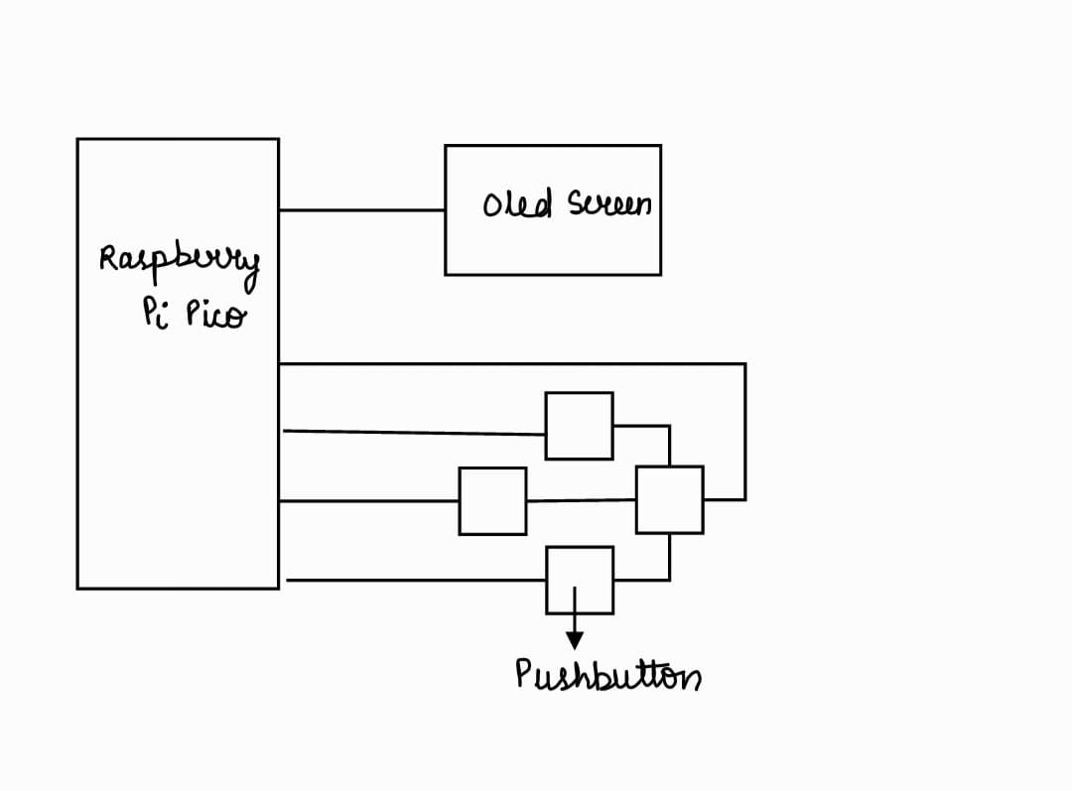

1. **Circuit Diagram of the project:**

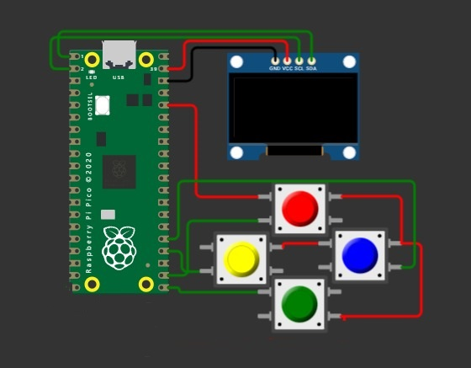

1. **Components/Items Required:**

|  |  |  |  |
| --- | --- | --- | --- |
| **Sl. No.** | **Name of the Components** | **Specification** | **Quantity** |
| **1** | **Raspberry Pi Pico** | **125 MHz** | **1** |
| **2** | **Oled screen** | **128×64 pixels** | **1** |
| **3** | **Resistors** | **10000 ohm** | **5** |
| **4** | **Pushbuttons** |  | **4** |
| **5** | **Buzzer** |  | **1** |
| **6** |  |  |  |
| **7** |  |  |  |
| **8** |  |  |  |

**The project synopsis should be verified by the corresponding faculties within 7 days. After getting the verified signature from the any one corresponding faculty, a group can proceed to buy the components.**

**Full Signature of Group members:**

**1.**

**2.**

**Signature of Corresponding Faculty**